On the Common Substring Alignment Problem
Gad M. Landau and Michal Ziv-Ukeson
Journal of Algorithms 41, 338-359, 2001
Abstract

- INTRODOUCTION

T=”DCBADBDC” Y=”DCBD”
S₁=”E DCBD DCBD” B₁=”E” F₁=”DCBD”
S₂=”CBA DCBD C” B₂=”CBA” F₂=”C”
2. APPLICATIONS
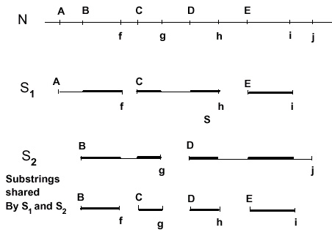
3. BACKGROUND

4. THE COMMON SUBSTRING ALIGNMENT APPROACH
4.1：Notation
4.2：Algorithm Framework
- Encoding Stage
- Alignment Stage
5. THE FIRST ALGORITHM
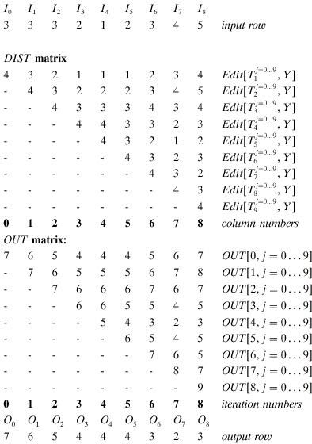

6. A MORE EFFICIENT, NON-RECURSIVE ALGORITHM
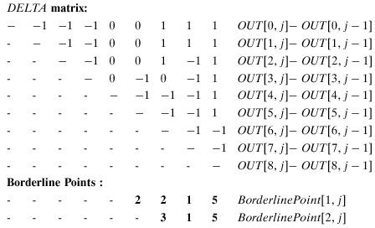
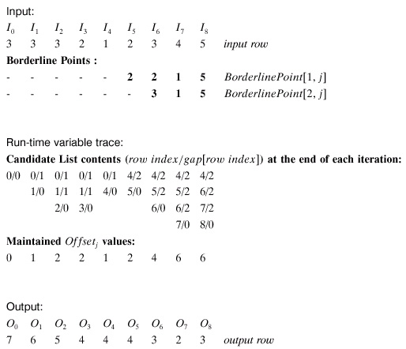
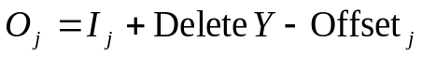
Created by: Ing-Jer Liao
Date: Oct. 25, 2002

